# Overview

This document contains the necessary information to build the device.

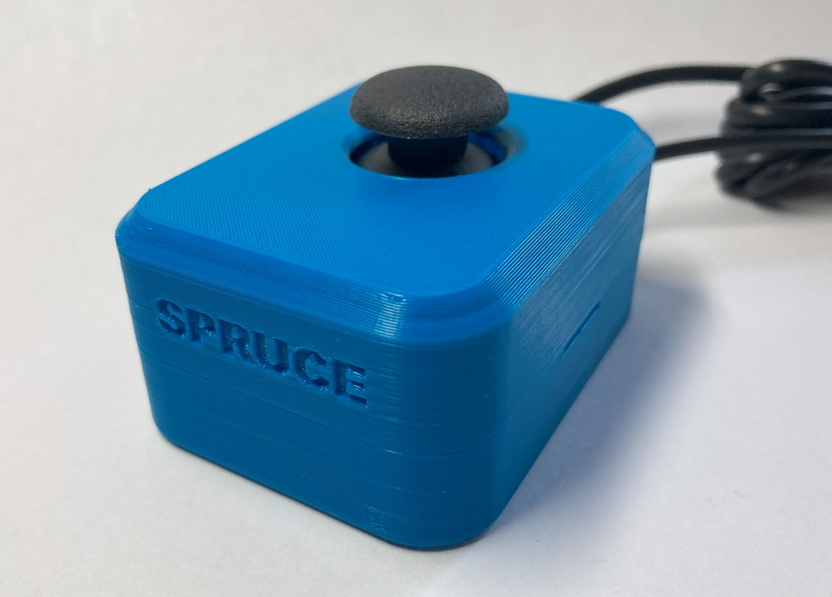

Contents

Overview 1

Maker Checklist 4

Maker To Do List 4

Items to Give to User 4

Tool List 5

Customization Guide 6

Joystick 6

Toppers 6

Mounting 6

3D Printing Guide 7

3D Printing Summary 7

3D Printing Settings 7

Spruce Mini Joystick Enclosure - Single Unit 7

Post-Processing 7

Examples of Quality Prints 7

Spruce_enclosure_bottom.stl 7

Spruce_enclosure_top.stl 8

Assembly Guide 9

Spruce Mini Joystick Assembly – Adafruit PS2 Joystick 10

Required Components 10

Tools and Personal Protective Equipment (PPE) 11

Required Tools 11

Optional Tools 11

Required Personal Protective Equipment (PPE) 11

Assembly Steps – Adafruit Joystick 12

Spruce Mini Joystick Assembly – Generic PS2 Joystick 21

Required Components 21

Tools and Personal Protective Equipment (PPE) 21

Required Tools 21

Optional Tools 21

Required Personal Protective Equipment (PPE) 21

Assembly Steps – Generic PS2 Joystick 22

Testing 31

Testing with a Multimeter **Error! Bookmark not defined.**

Test 1: Testing for Short Circuits **Error! Bookmark not defined.**

Test 2: Testing Vertical Joystick Axis **Error! Bookmark not defined.**

Test 3: Testing Horizontal Joystick Axis **Error! Bookmark not defined.**

Test 4: Testing Push Button 33

Testing using an USB-HID Gamepad Device 33

# Maker Checklist

This list provides an overview of the steps required to build and deliver the device.

## Maker To Do List

* Read through the Maker Guide to become familiar with required components, tools, supplies, and safety gear and overall assembly steps.
* Talk to User about customization options (e.g., colour, any special requests, etc.)
  + Enclosure Colour
  + Joystick Toppers
  + Mounting Options
  + USB Interfaces (e.g., Forest Hub)
* Order hardware components
* 3D print all 3D printed components.
* Gather tools, supplies, and safety equipment.
* Assemble the device.
* Test device.
* Print “User Guide”

## Items to Give to User

* Assembled, tested joystick
* Joystick toppers (if requested)
* Mounting Adapters (if requested)
* “User Guide”

# Tool List

* Flush Cutters
* Wire Strippers
* #3 Philips Head Screwdriver
* Pliers
* Soldering Iron and Solder
* Multimeter

# Customization Guide

## Joystick

The enclosure can be printed in the user’s desired colour. Using a colour swap after the first few layers can help to make the Up/Forward arrow stand out more.

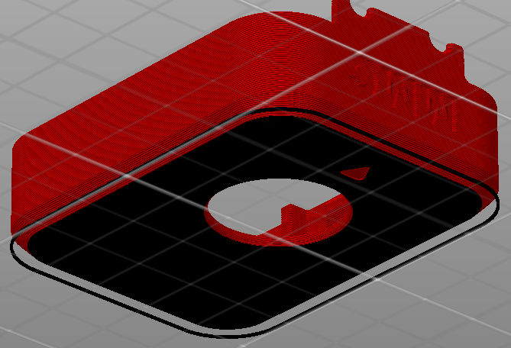

## Toppers

3D printed joystick toppers can be added to the joystick.

Any PS2 style thumbstick toppers will work here, one example is this [set of toppers designed by AbleGamers[1].](https://www.printables.com/model/501869-analog-thumbstick-topper-collection)

## Mounting

Mount adapters can be added for custom mounting solutions.

# 3D Printing Guide

## 3D Printing Summary

|  |  |
| --- | --- |
| **Metrics** | **Single Unit** |
| Total Print Time (min) | 3h08m |
| Total Number of Components | 2 |
| Typical Total Mass (g) | 28 |
| Typical Number of Print Setups | 1 |

## 3D Printing Settings

### Spruce Mini Joystick Enclosure - Single Unit

|  |  |  |  |  |  |  |  |
| --- | --- | --- | --- | --- | --- | --- | --- |
| **Print File Name** | **Qty** | **Total Print Time (hr:min)** | **Mass (g)** | **Infill (%)** | **Support (Y/N)** | **Layer Height/ Nozzle Diameter(mm)** | **Notes** |
| Spruce_enclosure_ bottom.stl | 1 | 1:46 | 16 | 20 | N | 0.2/0.4 | Print in given orientation |
| Spruce_enclosure_ top.stl | 1 | 1:22 | 12 | 20 | N | 0.2/0.4 | Print in given orientation |

## Post-Processing

* Remove any stringing or blobs

## Examples of Quality Prints

### Spruce_enclosure_bottom.stl

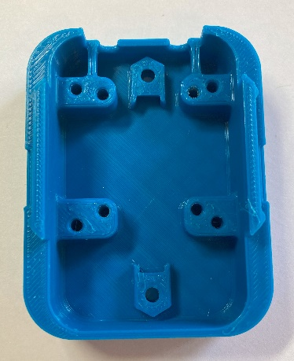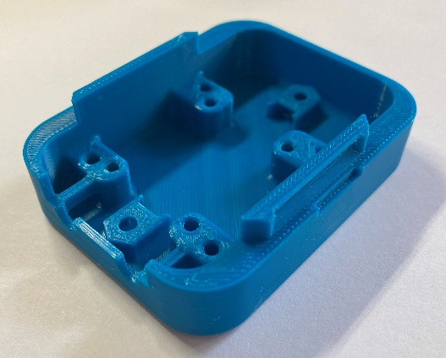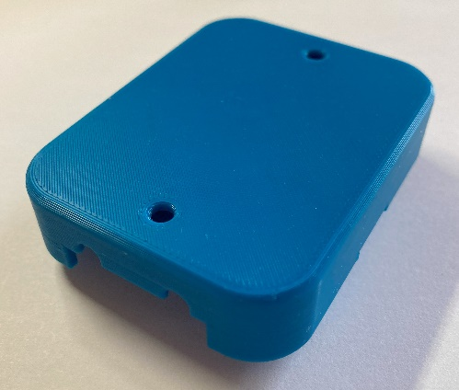

### Spruce_enclosure_top.stl

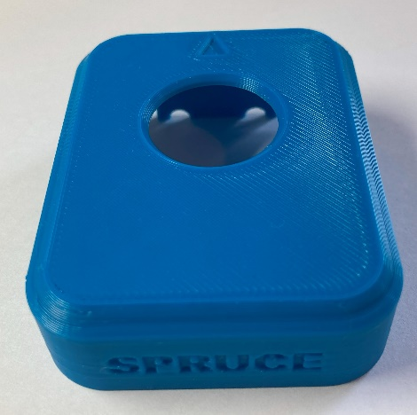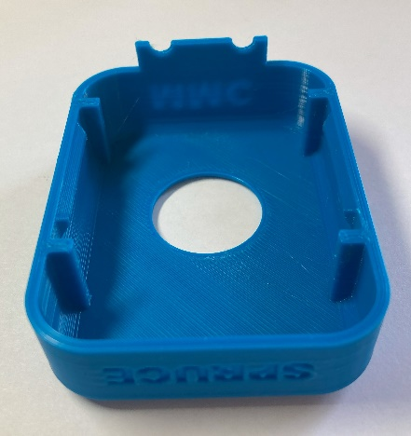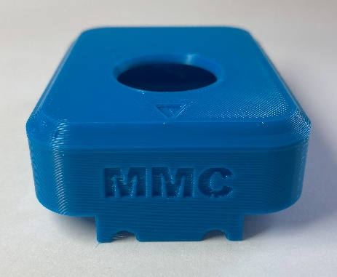

# Assembly Guide

Follow the instructions that correspond to the joystick module that you have.

|  |  |
| --- | --- |
| **Joystick Module** | **Assembly Instructions** |
| A photo of the joystick unit and Adafruit joystick breakout board. | Spruce Mini Joystick Assembly – Adafruit PS2 Joystick – Page 10 |
| A photo of the generic PS2 joystick module. | Spruce Mini Joystick Assembly – Generic PS2 Joystick – Page 10 |

## Spruce Mini Joystick Assembly – Adafruit PS2 Joystick

### Required Components

|  |  |  |  |  |  |  |  |  |
| --- | --- | --- | --- | --- | --- | --- | --- | --- |
| **1** | Adafruit PS2 Joystick | QTY 1 | **2** | TRRS Audio Cable | QTY 1 | **3** | Mono cable | QTY 1 |
| A photo of the joystick module and Adafruit joystick breakout board. | | | A photo of the Digikey TRRS audio cable. | | | A photo of the Digikey mono cable. | | |
| **4** | 4” cable tie | QTY 2 | **5** | #4 3/8” Screws, self threading | QTY 4 | **6** | M3 Hex Nuts | QTY 2 |
| A photo of two cable ties. | | | A photo of four metal #4 3/8" screws. | | | A photo of two metal M3 hex nuts. | | |
| **7** | 3D Printed Enclosure Bottom | QTY 1 | **8** | 3D Printed Enclosure Top | QTY 1 |
| A photo of the enclosure bottom printed in blue PLA. | | | A photo of the enclosure top printed in blue PLA. | | |

### Tools and Personal Protective Equipment (PPE)

|  |  |  |
| --- | --- | --- |
| Required Tools  * Flush Cutters * Wire Strippers * #3 Philips Screwdriver * Pliers * Soldering Iron and Solder * Multimeter | Optional Tools  * Electrical Continuity Tester (e.g., Multimeter) | Required Personal Protective Equipment (PPE)  * Safety Goggles |

### Assembly Steps – Adafruit Joystick

#### Step 1: Prepare Audio Cable

|  |  |
| --- | --- |
| If you are using the pre-prepared TRRS cable from DigiKey, pictured in the component list, you can skip this step.  If using a different cable, prepare the wires for soldering:   * Cut the TRRS cable to length (typically 1 m). * Strip off approximately 2 cm of the outer insulation. * Then, separate the 4 individual inner wires. If there are three insulated wires plus copper strands, twist these copper strands together to be one of your wires. If there are 4 insulated wires plus loose copper stranded wires, cut off these copper wires. * Strip off approximately 0.5 cm of insulation from the inner wires. * For each inner wire, twist the inner strands together | Cable with 4 smaller inner cables with insulation and small uninsulated wires to one side.  Cable with 4 smaller insulated wires coming out. The insulation has been stripped off of the ends. |

#### Step 2: Identify Audio Cable Wires

|  |  |
| --- | --- |
| If using the pre-prepared DigiKey cable, you can skip this step.  You should use a multimeter or other continuity tester to confirm which wire corresponds to which part of the plug. Follow this [guide for checking continuity](https://www.youtube.com/watch?v=T4p8UQZqh5U) to determine which wire corresponds to the Sleeve, Ring 1, Ring 2, and Tip of the TRRS cable plug. | A qr code on a white background linking to a guide for checking continuity. |

|  |  |  |
| --- | --- | --- |
| TRRS Plug | DigiKey cable | Your cable |
| Sleeve | Black |  |
| Ring 2 | Green |  |
| Ring 1 | White |  |
| Tip | Red |  |

#### Step 3: Prepare Mono Cable

|  |  |
| --- | --- |
| If you are using the pre-prepared mono cable from DigiKey, pictured in the component list, skip this step.  If using a different cable, you’ll need to prepare the wires for soldering:   * Cut the mono cable to length (typically 1 m). * Strip off approximately 2 cm of the outer insulation. * Then, separate the 2 individual inner wires. If there is one insulated wire plus copper strands, twist these copper strands together to be one of your wires. * Strip off approximately 0.5 cm of insulation from the inner wires. * For each inner wire, twist the inner strands together | A close-up of a cable with two smaller insulated wires coming out, with the ends of the insulation stripped off. |

#### Step 4: Insert Joystick into Breakout Board and Solder

|  |  |
| --- | --- |
| The Adafruit Joystick needs to be soldered to the Joystick breakout board before it is ready for use. | A photo of the joystick module and Adafruit joystick breakout board. |
| Carefully insert the joystick module into the joystick breakout board, ensuring all pins are inserted and the joystick is sitting flat. |  |
| Solder one (1) of the main joystick lugs. Ensure the joystick is flat against the breakout board, and then solder the remaining three (3) main lugs. |  |
| Solder the four (4) lead for the joystick switch. |  |
| Solder the three (3) leads for the X-axis potentiometer and three (3) leads for the Y-axis potentiometer. |  |
| The prepared joystick module. | A photo of the bottom of the Adafruit joystick breakout board with the joystick soldered on. |

#### Adafruit Joystick Wiring diagram

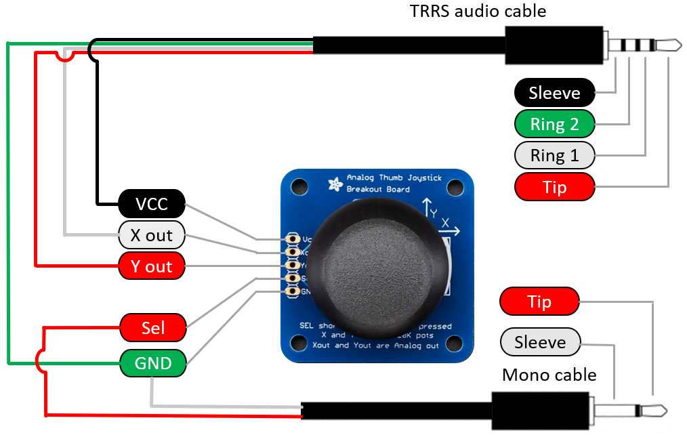

|  |  |  |  |  |  |  |
| --- | --- | --- | --- | --- | --- | --- |
| JOYSTICK BOARD Label | TRRS Plug | DigiKey TRRS Cable | Your TRRS  CABLE | Mono PLUG | Mono CABLE | Your Mono Cable |
| Sel | --- | --- |  | Tip | Red |  |
| Yout | Tip | Red |  | --- | --- |  |
| Xout | Ring 1 | White |  | --- | --- |  |
| Vcc | Sleeve | Black |  | --- | --- |  |
| GND | Ring 2 | Green |  | Sleeve | White |  |

#### Step 5: Solder TRRS Sleeve to Voltage (Vcc) Pad

|  |  |
| --- | --- |
| Insert the TRRS audio cable **sleeve** wire (black) into **Vcc pad** on the joystick breakout, and solder. | A photo of soldering the TRRS cable sleeve wire to the Adafruit joystick board VCC pad. |

#### Step 6: Solder TRRS R1 to X (Xout) Pad

|  |  |
| --- | --- |
| Insert the TRRS audio cable **ring 1** wire (white) into the **Xout pad** on the joystick breakout, and solder. | A photo of soldering the TRRS cable ring 1 wire to the Adafruit joystick board X out pad. |

#### Step 7: Solder TRRS Tip to Y (Yout) Pad

|  |  |
| --- | --- |
| Insert the TRRS audio cable **tip** wire (red) into the **Yout pad** on the joystick breakout, and solder. | A photo of soldering the TRRS cable tip wire to the Adafruit joystick board Y out pad. |

#### Step 8: Solder Mono Cable Tip to Switch (SW) Pad

|  |  |
| --- | --- |
| Insert the Mono audio cable **tip** wire (red) into the **Sel pad** on the joystick breakout, and solder. | A photo of soldering the mono cable tip wire to the Adafruit joystick board Sel pad. |

#### Step 9: Solder Mono Cable Sleeve and TRRS Cable R2 to Ground (GND) Pad

|  |  |
| --- | --- |
| Take both the mono audio cable **sleeve** wire (white) and the TRRS audio cable **Ring 2** wire (green) and insert into the **GND pad** on the joystick breakout. Solder. | A photo of soldering the TRRS cable ring 2 wire and mono cable sleeve wire to the Adafruit joystick board GND pad. |

#### Step 10: Clean up Wires

|  |  |
| --- | --- |
| Use flush cutters to trim any excess wires from the soldered pads. | A photo of the complete soldered Adafruit joystick. |

#### Step 11: Check for Shorts

|  |  |
| --- | --- |
| Inspect the board and check that none of the connections are shorted.  There should be no bridges/connections between adjacent pins.  If you have a multimeter, you can use it to double check continuity. | Warning icon |

#### Step 12: Insert M3 Hex Nuts into Enclosure Bottom

|  |  |
| --- | --- |
| Take the enclosure bottom and insert the M3 nuts into the slots as shown. You may require a tool such as needle-nosed pliers or a screwdriver to push the nuts into place. | A photo of the M3  nuts inserted into the enclosure bottom. |

#### Step 13: Position Joystick Unit

|  |  |
| --- | --- |
| Thread the two cables from the joystick unit out the two cutouts at the back of the enclosure.  Ensure that the cables go between the screw holes and the captive nut piece and won’t interfere with screwing down the joystick. | A photo of the cables being routed out of the enclosure before fastening the Adafruit joystick in place. |

#### Step 14: Screw in joystick unit

|  |  |
| --- | --- |
| Position the joystick unit over the screw holes. There are two (2) sets of screw holes for two different joystick units, find the set that matches your joystick.  Screw in all four (4) screws through the joystick unit and enclosure. Be careful not to over tighten. | A photo of the Adafruit joystick fastened into the enclosure bottom. |

#### Step 15: Fasten First Cable Tie

|  |
| --- |
| Thread the cable tie under the left cable and the 3D printed beam, going from the middle towards the edge.  Tighten the cable tie as much as you are able with your hands. The cable should now feel secure and unable to wiggle around.  Lastly, cut off the excess cable tie using flush cutters. |
| A photo of a cable tie wrapped around the first cable routed out of the enclosure bottom.A photo of a cable tie sinched tight around the first cable routed out of the enclosure bottom.A photo of a trimmed cable tie sinched tight around the first cable routed out of the enclosure bottom. |

#### Step 16: Fasten Second Cable Tie

|  |
| --- |
| Repeat with the second cable tie, thread the cable tie under the left cable and the 3D printed beam, going from the middle towards the edge.  Tighten the cable tie as much as you are able with your hands. The cable should now feel secure and unable to wiggle around.  Lastly, cut off the excess cable tie using flush cutters. |
| A photo of a cable tie wrapped around the second cable routed out of the enclosure bottom.A photo of a cable tie sinched tight around the second cable routed out of the enclosure bottom.A photo of a trimmed cable tie sinched tight around the second cable routed out of the enclosure bottom. |

#### Step 17: Assemble Enclosure

|  |  |
| --- | --- |
| Line up the enclosure top and apply downward pressure to snap it into place. | A photo of the completed Spruce Mini Joystick. |

Proceed to Testing.

## Spruce Mini Joystick Assembly – Generic PS2 Joystick

### Required Components

|  |  |  |  |  |  |  |  |  |
| --- | --- | --- | --- | --- | --- | --- | --- | --- |
| **1** | Generic PS2 Joystick | QTY 1 | **2** | TRRS Audio Cable | QTY 1 | **3** | Mono cable | QTY 1 |
| A photo of the generic PS2 joystick module. | | | A photo of the Digikey TRRS audio cable. | | | A photo of the Digikey mono cable. | | |
| **4** | 4” cable tie | QTY 2 | **5** | #4 3/8” Screws, self threading | QTY 4 | **6** | M3 Hex Nuts | QTY 2 |
| A photo of two cable ties. | | | A photo of four metal #4 3/8" screws. | | | A photo of two metal M3 hex nuts. | | |
| **7** | 3D Printed Enclosure Bottom | QTY 1 | **8** | 3D Printed Enclosure Top | QTY 1 |
| A photo of the enclosure bottom printed in blue PLA. | | | A photo of the enclosure top printed in blue PLA. | | |

### Tools and Personal Protective Equipment (PPE)

|  |  |  |
| --- | --- | --- |
| Required Tools  * Flush Cutters * Wire Strippers * #3 Philips Screwdriver * Pliers * Soldering Iron and Solder * Multimeter | Optional Tools  * Electrical Continuity Tester (e.g., Multimeter) | Required Personal Protective Equipment (PPE)  * Safety Goggles |

### Assembly Steps – Generic PS2 Joystick

#### Step 1: Prepare Audio Cable

|  |  |
| --- | --- |
| If you are using the pre-prepared TRRS cable from DigiKey, pictured in the component list, you can skip this step.  If using a different cable, prepare the wires for soldering:   * Cut the TRRS cable to length (typically 1 m). * Strip off approximately 2 cm of the outer insulation. * Then, separate the 4 individual inner wires. If there are three insulated wires plus copper strands, twist these copper strands together to be one of your wires. If there are 4 insulated wires plus loose copper stranded wires, cut off these copper wires. * Strip off approximately 0.5 cm of insulation from the inner wires. * For each inner wire, twist the inner strands together | Cable with 4 smaller inner cables with insulation and small uninsulated wires to one side.  Cable with 4 smaller insulated wires coming out. The insulation has been stripped off of the ends. |

#### Step 2: Identify Audio Cable Wires

|  |  |
| --- | --- |
| If using the pre-prepared DigiKey cable, you can skip this step.  You should use a multimeter or other continuity tester to confirm which wire corresponds to which part of the plug. Follow this [guide for checking continuity](https://www.youtube.com/watch?v=T4p8UQZqh5U) to determine which wire corresponds to the Sleeve, Ring 1, Ring 2, and Tip of the TRRS cable plug. | A qr code on a white background linking to a guide for checking continuity. |

|  |  |  |
| --- | --- | --- |
| TRRS Plug | Digikey cable | Your cable |
| Sleeve | Black |  |
| Ring 2 | Green |  |
| Ring 1 | White |  |
| Tip | Red |  |

#### Step 3: Prepare Mono Cable

|  |  |
| --- | --- |
| If you are using the pre-prepared mono cable from DigiKey, pictured in the component list, skip this step.  If using a different cable, you’ll need to prepare the wires for soldering:   * Cut the mono cable to length (typically 1 m). * Strip off approximately 2 cm of the outer insulation. * Then, separate the 2 individual inner wires. If there is one insulated wire plus copper strands, twist these copper strands together to be one of your wires. * Strip off approximately 0.5 cm of insulation from the inner wires. * For each inner wire, twist the inner strands together | A close-up of a cable with two smaller insulated wires coming out, with the ends of the insulation stripped off. |

#### Step 4: Pre-tin Wires and Header Pins

|  |  |
| --- | --- |
| Pre-tin the wires and the headers by melting a small amount of solder onto them so they are silver and shiny.  Do this to each of the 4 wires on the audio cable, both wires on the mono cable, and each of the 5 pins on the joystick unit. | A cable with 4 smaller wires coming out of it, the ends of the wires are shiny because they have been tinned. A cable with 2 smaller wires coming out of it, the ends of the wires are shiny because they have been tinned.  A close up of 5 pin male angled headers, the ends are shiny because they have been pre-tinned. |

#### Wiring diagram

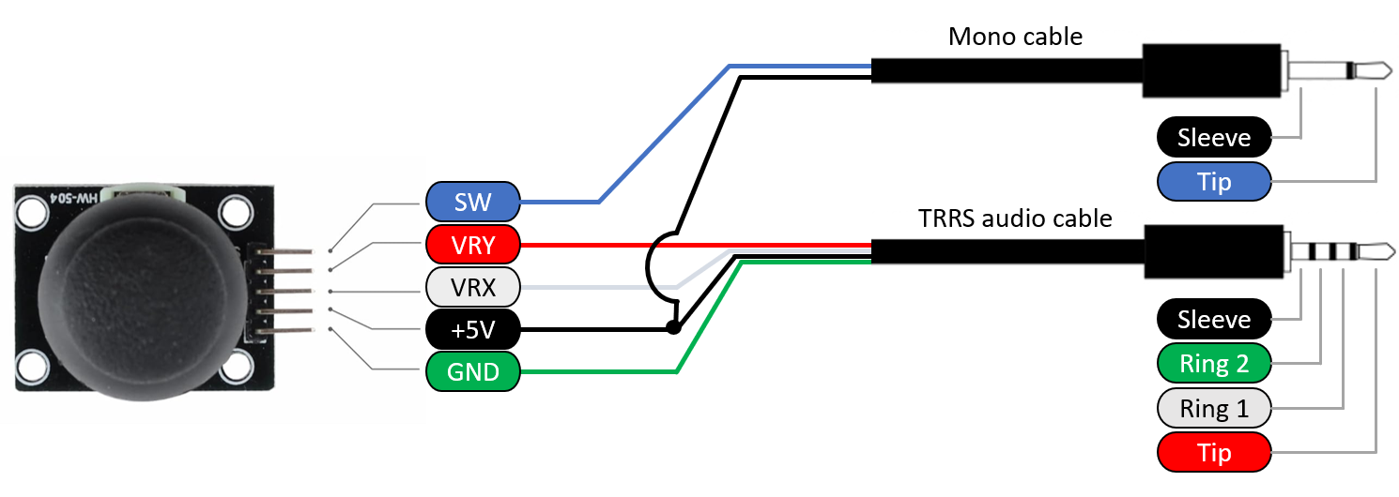

|  |  |  |  |  |
| --- | --- | --- | --- | --- |
| JOYSTICK BOARD Label | Digikey TRRS cable | TRRS Plug | Mono CABLE | MONO PLUG |
| SW | --- | --- | Red | Tip |
| VRY | Red | Tip |  | --- |
| VRX | White | Ring 1 |  | --- |
| +5V | Black | Sleeve |  | --- |
| GND | Green | Ring 2 | White | Sleeve |

#### Step 5: Solder Voltage (+5V) Pin

|  |  |
| --- | --- |
| Take the wire from the TRRS audio cable that corresponds to the **sleeve**, line this wire up with the **+5V pin** on the joystick unit, and solder together.  On the audio cable from DigiKey, this will be the **black wire.**  Note: Try to get the insulation on the wire as close as possible to the edge of the header pin, so there is less wire that can move and touch other wires. | A close up of 5 pin male angled headers, with a black wire soldered to the 5V pin. |

#### Step 6: Solder X (VRX) Pin

|  |  |
| --- | --- |
| Take the wire from the TRRS audio cable that corresponds to **ring 1**, line this wire up with the **VRX pin** on the joystick unit, and solder together.  On the audio cable from DigiKey, this will be the **white wire.**  Note: Try to get the insulation on the wire as close as possible to the edge of the header pin, so there is less wire that can move and touch other wires. | A close up of 5 pin male angled headers, with a black wire soldered to the 5V pin, and white wire soldered to the VRX pin. |

#### Step 7: Solder Ground (GND) Pin

|  |  |
| --- | --- |
| Take the wire from the audio cable that corresponds to **ring 2**, line this wire up with the **GND pin** on the joystick unit, and solder together.  On the audio cable from DigiKey, this will be the **green wire.**  Note: Try to get the insulation on the wire as close as possible to the edge of the header pin, so there is less wire that can move and touch other wires. | A close up of 5 pin male angled headers, with a black wire soldered to the 5V pin, , white wire soldered to the VRX pin, and green wire soldered to the GND pin. |

#### Step 8: Solder Y (VRY) Pin

|  |  |
| --- | --- |
| Take the wire from the audio cable that corresponds to **the tip**, line this wire up with the **VRY pin** on the joystick unit, and solder together.  On the audio cable from DigiKey, this will be the **red wire.**  Note: Try to get the insulation on the wire as close as possible to the edge of the header pin, so there is less wire that can move and touch other wires. | A close up of 5 pin male angled headers, with a black wire soldered to the 5V pin, , white wire soldered to the VRX pin, green wire soldered to the GND pin, and red wire soldered to the VRY pin. |

#### Step 9: Solder Mono cable to Ground (GND) Pin

|  |  |
| --- | --- |
| Take either one of the wires from the mono cable, line it up with the **GND pin** on the joystick unit, and solder together.  Note: Try to get the insulation on the wire as close as possible to the edge of the header pin, so there is less wire that can move and touch other wires. | A close up of 5 pin male angled headers, with the TRRS audio cable soldered in place and the red wire of the mono cable soldered to the GND pin. |

#### Step 10: Solder Mono Cable to Switch (SW) Pin

|  |  |
| --- | --- |
| Take the remaining wire from the mono cable, line it up with the **SW pin** on the joystick unit, and solder together.  Note: Try to get the insulation on the wire as close as possible to the edge of the header pin, so there is less wire that can move and touch other wires. | A close up of 5 pin male angled headers, with the TRRS audio cable soldered in place the red wire of the mono cable soldered to the GND pin, and the black wire of the mono cable soldered to the Sel pin.. |

#### Step 11: Check for Shorts

|  |  |
| --- | --- |
| Inspect the board and check that none of the connections are shorted.  There should be no bridges/connections between adjacent pins.  If you have a multimeter, you can use it to double check continuity. | Warning with solid fill |

#### Step 12: Insert M3 Hex Nuts into Enclosure Bottom

|  |  |
| --- | --- |
| Take the enclosure bottom and insert the M3 nuts into the slots as shown. You may require a tool such as needle-nosed pliers or a screwdriver to push the nuts into place. | A photo of the M3 nuts being inserted into the enclosure bottom. A photo of the M3 nuts inserted into the enclosure bottom. |

#### Step 13: Position Joystick Unit

|  |  |
| --- | --- |
| Thread the two cables from the joystick unit out the two cutouts at the back of the enclosure.  Ensure that the cables go between the screw holes and the captive nut piece and won’t interfere with screwing down the joystick. | A photo of the cables being routed in the enclosure bottom. |

#### Step 14: Screw in joystick unit

|  |  |
| --- | --- |
| Position the joystick unit over the screw holes. There are two sets of screw holes for two different joystick units, find the set that matches your joystick module.  Screw in all four screws through the joystick unit and enclosure. Be careful not to over tighten. | A photo of the joystick module fasten into the enclosure bottom. |

#### Step 15: Check for Shorts

|  |  |
| --- | --- |
| Visually inspect the board and check that none of the connections are shorted.  There should be no bridges/connections between adjacent pins.  If you have a multimeter, you can use it to double check continuity. | Warning icon |

#### Step 16: Fasten First Cable Tie

|  |
| --- |
| Thread the cable tie under the left cable and the 3D printed beam, going from the middle towards the edge.  Tighten the cable tie as much as you are able with your hands. The cable should now feel secure and unable to wiggle around.  Lastly, use flush cutters to cut off the excess cable tie. |
| A photo of a cable tie wrapped around the first cable routed out of the enclosure bottom. A photo of a cable tie sinched tight around the first cable routed out of the enclosure bottom. A photo of a trimmed cable tie sinched tight around the first cable routed out of the enclosure bottom. |

#### Step 17: Fasten Second Cable Tie

|  |
| --- |
| Repeat with the second cable tie, thread the cable tie under the left cable and the 3D printed beam, going from the middle towards the edge.  Tighten the cable tie as much as you are able with your hands. The cable should now feel secure and unable to wiggle around.  Lastly, use flush cutters to cut off the excess cable tie. |
| A photo of a cable tie sinched tight around the second cable routed out of the enclosure bottom. A photo of a trimmed cable tie sinched tight around the second cable routed out of the enclosure bottom. |

#### Step 18: Assemble Enclosure

|  |  |
| --- | --- |
| Line up the enclosure top and apply downward pressure to snap it into place. | A photo of the completed Spruce Mini Joystick. |

Proceed to Testing.

# Testing

## Testing using a Multimeter

A multimeter can be used to test if the wires are connected and soldered correctly. It is most important to ensure that there is no short circuit between the Sleeve (Ground) and Tip (Voltage), as this can damage the host device. It can be tricky to place the probes and move the joystick, so tape, or a second person can be helpful here.

**Note:** The intended joystick for this build has two 10 KΩ potentiometers, but some joysticks use 5 KΩ potentiometers, which will result in the expected multimeter readings to be halved

### Test 1: Testing for Short Circuits

|  |  |
| --- | --- |
| 1. Set the multimeter to measure resistance in the 1-10 KΩ range. 2. Hold the tip of the red probe of the multimeter to the Sleeve (Voltage) of the TRRS cable. 3. Hold the tip of the black probe of the multimeter to Ring 2 (Ground) on the TRRS cable. 4. Confirm that the resistance is between 4 – 5 KΩ.    1. Between 4 – 5 KΩ: No shorts. Proceed to next test.    2. Less than 50 Ω: There is a short circuit between a Ground and Voltage pin (Pins 1, 3, 4, and 6). This must be fixed to prevent damaging a host device. Open the joystick and review/fix your soldering joints.    3. Other values: There is a wiring problem. Open the joystick and review/fix your soldering joints. |  |

If you have no short circuits, you can move on to testing the joystick directions. This can be done with either the multimeter, or with a USB-HID gamepad that accepts an analog joystick.

### Test 2: Testing Vertical Joystick Axis

|  |  |
| --- | --- |
| 1. Hold the tip of the red probe of the multimeter to the Sleeve (Voltage) of the TRRS cable. 2. Hold the tip of the black probe to Ring 1 (Y-axis) on the TRRS cable. 3. While holding the multimeter probes in place, move the joystick fully in the UP ↑ direction.    1. You may require a second person to hold the probes in place or move the joystick.    2. Otherwise, the joystick can be held in place with some tape to leave your hands free to hold the multimeter probes in place. 4. Read the resistance on the multimeter:    1. Less than .05 KΩ: The Y-axis potentiometer is wired correctly.    2. Otherwise, review the wiring diagram and ensure your wiring matches. 5. Release the joystick back to neutral position. |  |

### Test 3: Testing Horizontal Joystick Axis

|  |  |
| --- | --- |
| 1. Hold the tip of the red probe of the multimeter to the Sleeve (Voltage) of the TRRS cable. 2. Hold the tip of the black probe to Tip (X-axis) of the TRRS cable. 3. While holding the multimeter probes in place, move the joystick fully in the RIGHT → direction.    1. You may require a second person to hold the probes in place or move the joystick.    2. Otherwise, the joystick can be held in place with some tape to leave your hands free to hold the multimeter probes in place. 4. Read the resistance on the multimeter.    1. Less than .05 KΩ: The X-axis potentiometer is wired correctly.    2. Otherwise, review the wiring diagram and ensure your wiring matches. 5. Release the joystick back to neutral position. |  |

### Test 4: Testing Push Button

|  |  |
| --- | --- |
| 1. Change the multimeter to continuity checking mode. 2. Hold the tip of the red probe to the Sleeve (Sel) of the mono cable. 3. Hold the tip of the black probe to the Tip (GND) of the mono cable. 4. While holding the probes in place, push on the joystick to activate the button.    1. You may require a second person to hold the probes in place or push the joystick.    2. Otherwise, the joystick can be held down with some tape to leave your hands free to hold the multimeter probes in place. 5. Listen for the multimeter to beep.    1. While the joystick is pressed, the multimeter should emit a sound.    2. When not pressed, the multimeter should be quiet. |  |

## Testing using an USB-HID Gamepad Device

1. Plug the joystick into analog joystick input for the host device.
   1. X1 or X2 on an Xbox Adaptive Controller.
   2. Plug the mono cable into the A switch jack on an Xbox Adaptive Controller.
2. Plug the host device into your laptop.
3. If using Windows, open “Set up USB Game Controllers” from the Control Panel. You can find this by searching your computer in the search bar next to the Windows icon.
   1. If using a Mac, use <https://hardwaretester.com/gamepad>
4. Select the host device from the list of controllers and go to “Properties”.
5. Move your joystick and observe the movement of the cross hatch in the “Axes” window. Ensure it moves in the proper directions when you move the joystick (the arrow points in the up direction). If not, open the joystick and check your connections.
6. Push the joystick to activate the button.
   1. You should see the button activate on whichever testing system you are using, respective of which switch port you plugged the cable into.

1. <https://www.printables.com/model/501869-analog-thumbstick-topper-collection>